St. Nicholas’ Church

Annual Parochial Church Meeting Sunday 30th April 2017

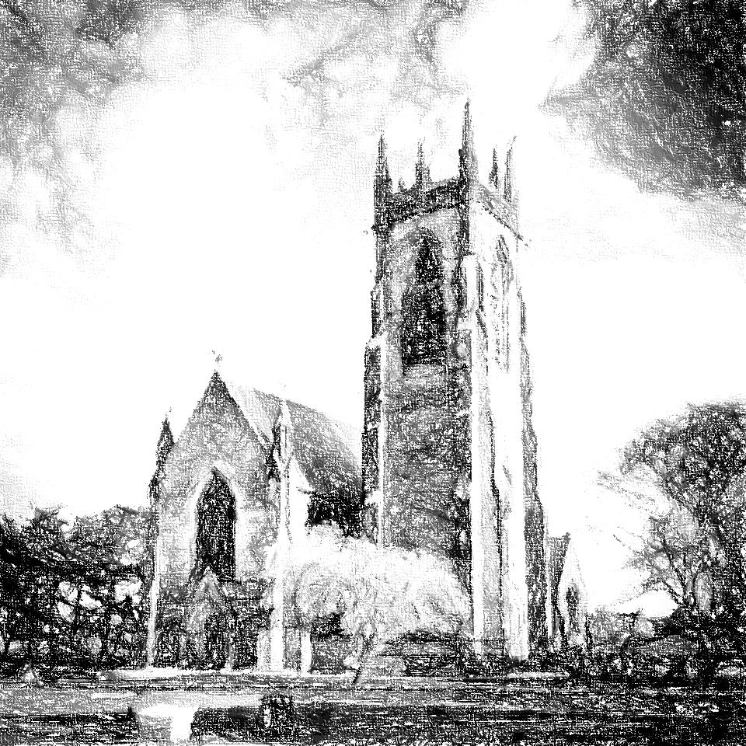
St. Nicholas’ Church, Beverley, East Yorkshire
Bankers: NatWest
Independent Examiner: S.R. Dawson
Church Architect: Jonathan Hobson, Holmechurch Lane, Beverley

2016/17 Annual Report on the Proceedings of the PCC & Activities of the Parish
Background:
The Parochial Church Council (PCC) of St. Nicholas, Beverley has the responsibility of co-operating with the incumbent, in promoting in the ecclesiastical parish the whole mission of the church, pastoral, evangelistic, social and ecumenical. The PCC is a charity excepted from registration with the Charity Commission. Members of the PCC are either ex officio or elected by the annual parochial church meeting in accordance with the Church Representation Rules.

Following the AGM the following served as members of the PCC
The Incumbent: Revd Richard Walker
The Churchwardens; Mrs. W. Wilson (also vice chair,) Mrs. S. Lambert
Exofficio members: Revd Simon Bray
Deanery Synod Reps: Mrs. S Thomson; Miss B. Spivey
Lay Reader: Mrs. A. Smith
The elected members from the APCM held on Sunday 24th April 2016 were:
Mr. Stuart Carr Minutes Secretary
Mr. Steve Whitehead Treasurer
Mrs. Katherine Steel Electoral Roll Officer and PCC Secretary
Mrs. Helga Stephens, Mr. P. Steele, Mr. Tom Langdale, Mrs. Fran Powers, Mr. J. Wardle, Mr. Eric Dean;
Co-opted members: Mr. M. Walker, Mrs. P. Towse

Standing Committee
This is the only committee required by law. It has the power to transact the business of the PCC between its meetings, subject to any direction given by the council. It met four times in the year 2015-2016

Electoral Roll
Mrs. K. Steel (electoral roll officer) revised the roll for 2016. The Electoral Roll for St. Nicholas’ Church, Beverley was reported as follows: -
Inside Parish - 36
Outside Parish - 28
Total - 64

Church Attendance/Ceremonies 2016

Weddings - 5

Funerals – 10 plus 8 Cremations separate from St.Nics
Baptisms - 23
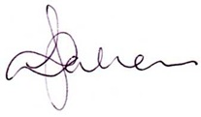
Christmas Eve or Christmas Day Service – 84 and 131 people respectively
Prepared on behalf of the PCC
Mrs. Katherine Steel – Secretary to St. Nicholas’ PCC

Signed Date Saturday, 08 April 2017

Dates of PCC and Standing Committee Meetings 2016/17
PCC Meetings Standing Committees
Sun 30th April (following APCM)
Mon 15th May (with Eucharist) Mon 12th June
Mon 10th July Thurs 10th August
Mon 11th September Tues 10th October
Thurs 9th November Mon 11th December
Tues 9th January 2018 Thurs 8th February 2018
Tues 20th March 2018 Mon 9th April 2018
APCM Sun 30th April 2018

Vicar’s Report
The way to build a church is not to pay for it, certainly not with somebody else's money.
The way to build a church is not even to pay for it with your own money.
The way to build a church is to build it.
St. Francis of Assisi
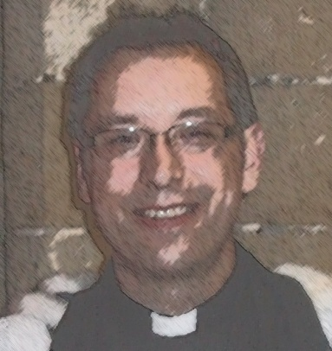
Over the last four years I have reflected upon the nature of the Christian community here at St. Nic’s and what strikes me is the way that the ministry of our members naturally follows something of St. Francis’ example. Our concern for the poor and needy by getting involved with Food bank and community lunches; or our commitment to the mission of HARP or CMS, or just giving away 10% of our finances are examples of this. There is another way in which we are like St. Francis too. Take the quote above, when you first read it, it is clear that Francis is talking about building a church “stone by stone,” a line taken from one of the songs in the 1961 film directed by Michael Curtiz. When Francis first heard God say “rebuild my church” he did take it literally and started rebuilding the church of San Damiano in Assisi. As a community, I have valued the commitment of St. Nic’s to its building and this year has been no less the case. Through the generosity of its members and the wider community, stone by stone we have virtually rebuilt the south transept window and put deluxe seat cushions on every pew.
Our building is important not just for us who gather here each week, but for the whole community. The “black church” is what the parish affectionately calls St. Nic’s and I suppose that they mean it is different from the two white churches in town. As the black church, it is clear that the community assign it with an identity. To have a church building is to possess a sign of Christian life within the parish, but a sign is not an end to a means, rather a means to an end. The sign of St. Nic’s points to something real and significant, just as St. Francis came to learn that what God had said was not confined to a physical building, rather he was being called to rebuild the church as a living community. Naturally his simple ministry to the poor became a reflection of that essential truth. When we as a community focus on the church as the building to the exclusion of all else we start to fail in the mission that God has given us here and now. We stop being that sign, when we fail to point to the greater reality of life. Like John the Baptist our mission, the thing that should be on the signpost of our lives is “Here is the Lamb of God who takes away the sin of the world!” (John 1:29) We are called to rebuild the church and each tell our story of how Jesus has met with us in the times of our need and that he can do the same for our neighbours and friends and those we meet. Francis is often misquoted as saying “preach the gospel and if necessary use words.” The implication is that we just need to show deeds of love and that is the gospel. Well not wanting to burst any Franciscan bubbles, but none of the written sources from St. Francis mention that he said those words. If he had he would have contradicted another Saint: Paul who said “And how are they to believe in one of whom they have never heard? And how are they to hear without someone to proclaim him?” (Roman 10:14). We are called to point to Jesus, open our mouths and say what he has done: that’s the challenge for us! In the same way, the Franciscans became renowned for preaching on the streets.
Having said all of that our church is growing. I’ve included a graph of the church attendance from the 10am Sunday service, which deliberately reproduces the maximum numbers from each year (these represent the baptismal services) and the minimum ones too. This plot gives us the interquartile ranges, which for those that haven’t got a clue about such things, they tell us where the most common church attendances are found either side of a middle value. So in 2016, 50% of our services had between 38 and 54 people with an average of 48. That grew from 2015, where 50% of our services numbered from 37 to 43 with a mean of 43. Folks that is good news! Four years ago, the Wednesday morning communion service had on average 11 people attending and this last year we were regularly at 20 people with a mean of 14.
Of course we did concentrate on growing our church through LYCIG (Leading your Church into growth) in the lent course and the START course. Attendance at these felt a little underwhelming. However, I sense that the Lord has grown our church more because he has seen our desire than our efforts to invite or provide events for people. Unfortunately, this is set against a backcloth of losing important people and saying sad farewells to Revd John Waud and John Wardle both of whom have contributed significantly to the life and ministry of St.Nic’s in the past. We miss them both. On a more positive note, it was lovely to welcome Brian and Caroline Lees to our church and see how easily that they have both fitted in with the ministry of the church.
This year we have re-established a monthly team meeting to oversee the pastoral work of the church and it has been wonderful to watch Simon successfully encourage our network of house groups into life. This team also develops the themes and readings of the sermons, which are another means of growing the church. We have looked at the meaning of the Resurrection, the Gospel in Galatians, Priorities in Luke’s Gospel, Good news in Acts, and asked what the church should look like in both Advent and the weeks following epiphany. I hope that you have found these themes helpful for your spiritual life. Another achievement is that our Website is up and running: Hurray! We have also delivered on a promise from the last APCM that all of our Baptisms will be held within the main service. Brian oversees this ministry. We now need to work on how we can provide a follow-up for each family. Nicola Bray became our Parish Administrator last September after Charlotte left for new pastures. Nicola has started to link the activities of the Parish centre more closely with the mission of the church. One of those steps will be to liaise with our baptism families, booking them in for their service and providing details of the Toddler group, which she runs each Thursday.
It has been a blessing to work alongside Simon and Brian, who have allowed me some time to concentrate on the training part of my role. That has meant I could guide four candidates through the discernment of their vocation; facilitate two RPA course; continue to teach and direct a module on the reader course and the Mission Shaped Ministry course and help run a second Diocesan LYCIG course. One of the aims that I came to St.Nic’s with was to enable this church to be a venue for training throughout the Archdeaconry. St. Nic’s has really been put on the map this year with Churchwarden training, Training Incumbents, Safeguarding and LYCIG events throughout the year. The seat cushions have been a real hit!
This leads me to my departure. In January I was very pleased to be offered the post of Vicar of St. Mary’s with Holy Apostles’ in Scarborough. Yes it’s by the seaside, but I have to say that I was not looking to move back into full time parish ministry at all. However the circumstances leading us to this (a place where I trained) have the haul-marks of God’s calling on them and so in June we will say our farewells to St. Nic’s with real sadness and not a little trepidation. I would like to reiterate the remarks that I made when I announced my resignation: our time at St.Nic’s has really restored my faith in the loveliness and generosity of the church. For that is what you have been to us and for that you will always have a special place in our hearts. So I would like to thank you for this gift and for all the hard work that you put in, because in so many ways you as a congregation know that the way to build a church: is just to build it! Take courage, point to Jesus and tell your story of how he has met with you. With blessings for your future life in Jesus, Richard

Curate’s Report
Thank you for your continuing support and encouragement in my first full year in ordained ministry. I was ordained priest (or presbyter) in May 2016, and it’s been my privilege to begin presiding at Communion at St Nick’s and to officiate at weddings. My time continues to be divided between many different things, including of course ongoing training as well as the regular services here, funerals, the development and adaptation of baptism ministry, and other whole church activities such as LYCIG Local and the Start! Course.

Autumn 2016 saw the launch of our new home groups. My great thanks go to our home group leaders and hosts - Ann, Helga, Eric, Carl, Pascale, Mary and Liz. It has been great to see these groups get underway and begin to flourish. Prayer together continues to be an area I would love to help us develop, as it will surely be the root and heart of anything fruitful we hope to do. The page, however, remains rather blank at present. St Nicholas School have visited the church a number of times, and in addition to helping with occasional assemblies I have now been co-opted as a Community Governor.

Preaching and leading the music for our service at the Folk Festival was one of the highlights of the year, notwithstanding a number of technical difficulties. Music group generally has a couple of new members (both drummers, one somewhat more experienced than the other). We have moved from a short weekly gathering to a longer monthly one, which seems to be working well, allowing for more time to actually make music, to develop in our understanding of our ministry in music and worship, and to train ourselves musically and spiritually. Another highlight of the year for me was preparing our confirmation candidates for their confirmation in December. The confirmation service itself was a great occasion, and we are praying and working both at St Nicks and with other churches in Beverley towards a way of supporting those candidates, particularly the young people, in their continuing journey of faith. Beyond the parish I am involved in helping to lead the local New Wine Church Leaders’ Network, I lead worship at the Wolds Filling Station from time to time, and I have helped with a number of Diocesan training events, as well as a few other events for other churches.

I am grateful to God for his grace in continuing to grow our church in number and in commitment, and I look forward to seeing how he will lead us in the year to come, and helping us to follow him. Simon Bray

Church Wardens’ Report 2017
The major achievement this year has been the repair to the South West transept window. This was a major job done under faculty. As a church we were well prepared for the upheaval, but definitely not for the dust which was everywhere! We managed to continue with services as usual – though the Flint Room proved quite a challenge at times. Accessing the cupboards behind the plastic sheeting was a difficult and dusty experience! The repair took longer than the original time estimate. Everyone heaved a sigh of relief when it was completed and many thanks go to Paul and Carol who gave up much of their time to allow contractors etc. access to the church building. We followed this relief with having the church deep cleaned. The Merry Maids did a brilliant job – the dust was a thing of the past!
Another major achievement this year was the acquisition of seat cushions. These have not only brightened the church but make sitting more comfortable. These cushions were paid for by two generous donations.
We continue to have problems with the drains, which we tried to tackle by installing hand dryers in the toilets. In addition an outside tap has been fitted towards the back of the old vestry so that the drains can be flushed out easily. The lap-top began to struggle – often not responding when needed so a replacement has been bought and so far so good!
It was back to donning the Marigolds when the dishwasher developed a serious problem which, after investigation, was going to be extremely expensive to repair. After some consideration it was decided it wasn’t worth repairing and as we were offered the donation of a second hand machine it was not a difficult decision. This is now successfully installed so the Marigolds can go back into the cupboard! Unfortunately the silver ciborium broke and after several enquiries it was decided that it wasn’t possible to repair it. This was because a previous repair had used the wrong solder and melting it off again would have damaged the silver. Fortunately a replacement has been generously donated.
The hinge on the altar rail was beginning to show signs of wear and becoming unsafe when the rail was being opened and closed. With considerable expertise Paul Steele has obtained a replacement brass hinge (from a marine store) and has replaced it. The sanctuary step has also been re-stained and now looks much better.
So in conclusion this has been a busy and sometimes challenging year, and certainly a steep learning curve for one of us! We give many thanks to all those who have helped, encouraged and supported us. Wendy and Sarah
The Wardens have asked me, on behalf of the PCC, to mention particularly the unstinting help from Paul which they have received throughout the year. On too many occasions to enumerate, Paul has offered a presence when workmen have been in church, expertise as in unblocking the drains, historical research when this has been needed and has been an absolute star aiding in the smooth running of the church. Thank you Paul! Kath Steel (Secretary)
Safeguarding Report
Our church has established policies for safeguarding both children and vulnerable adults. These are due to be reviewed by the new PCC. However as the diocese are currently working on a new combined policy, apparently to be available very soon, I am hopeful that we will be able to get one updated policy in place in the near future.
All requirements related to displaying safeguarding information have been completed, and efforts have been made to ensure that the congregation are aware of who to contact if they have any concerns related to the safety and protection of both children and vulnerable adults.
The main focus for the last year has been the ongoing processing of DBS forms, Confidential Declarations forms, and references for all those involved in both children’s work and the pastoral care team. I am happy to report that this has finally been achieved! All these last for five years when the process will need to be repeated.
In the year ahead there are to be significant changes in the safeguarding requirements and guidelines of the Diocese of York. The key message is that we should all be vigilant and therefore the Diocese have decided that all PCC members now need to be DBS checked. This is because the trustees of a children’s or vulnerable adults’ charity are required to be checked by the Charities Commission. Members of the PCC are by definition trustees of such a charity and as such now need to be willing to undergo the required checking procedure. This will include producing identifying documentation which will need to be verified by Richard, and then Simon during the interregnum. In addition the DBS checking of PCC members is recommended by the Ecclesiastical Insurance company with whom we are insured.
It has been suggested that the checking procedure should be completed by the end of July, and, to ease the pressure of paperwork, a preferred online system of DBS checking is planned to be ready by 01/05/17. Having said this it will still be possible to use the current system of completing a paper copy for people who are not keen on using technology! Those people who have already been checked in other roles within the church will not need to repeat the process until five years from certificate issue have elapsed. Obviously these requirements will impact upon our new PCC, but the same will also now apply to Recognised Parish Assistants and anyone transporting children or vulnerable adults on behalf of the church. Safeguarding training at differentiated levels will also need to be completed by PCC members, those involved in helping with or leading children’s work, the Pastoral Care team, Churchwardens. the Parish Safeguarding Representative, and of course the clergy. (A number of people are involved in more than one of these so it isn’t as onerous as it might initially seem.) The level of training increases with people’s level of responsibility/involvement but the PCC will only need to complete the most basic level of safeguarding training which will also be available to complete online.
These are major changes but we must keep sight of the aim which is to ensure the safety and protection of our children and vulnerable adults. To quote the guidelines ‘Safeguarding is the responsibility of EVERYONE!’. However if you have any questions or concerns or want to discuss the issues within this report, do please approach either myself, Richard or Simon. Sarah Lambert
Pastoral Team Report 2016/17

This year has seen the Pastoral Team continuing as last year, taking communion to a member of our church who was housebound and reaching out to those who have been bereaved. This is particularly valuable we feel, as sometimes it leads to helpful discussions and occasionally longer term contacts. The Bereavement Service took place again this year and we welcomed into church families who have been bereaved – not necessarily in the past year, but those who see this service as a good opportunity to remember their loved one within the sanctity of the church. If you would like someone to talk to, all members of our team have taken at least one course in Christian Listening Skills and would offer our services to those who would like a friendly, confidential ear. Mary, Joan, Sarah, Kath

Sunday School Report 2017
Our Sunday school is running well at the moment. We now have a team of people to cover each Sunday with both a teacher and a supporter which helps us comply with “safeguarding guide lines”. We are most grateful to the people who offered to support the team and we thank God for them - It is wonderful that people are happy to give of their time in supporting our children to explore the Bible and to hear the stories of God. We are now finding this more manageable. Numbers each week are usually average around - 6 or 7 and then occasionally there are more – depending on visitors or, on one occasion a few weeks ago, when lots of baptism children came in! Most weeks we prepare a lesson based on the readings for that week if possible. Occasionally, this is inappropriate or not possible - in which case we may do a Godly Play lesson or something topical or an old favourite! The team are excited at the moment with the project to give the Sunday school room a “new and brighter look”. We are very grateful for the donation of £500 which kick- started our plans and we aim to meet regularly to discuss the plans. One of the main issues is de-cluttering and we are hoping that once the room has been cleared and decorated etc. that it will remain free of clutter and avoid being used as storage room. We were all agreed that it is important to have light and space in the room - plus areas for quiet time and lots of colour etc. We would welcome any help in the form of ideas or practical support from the congregation in this matter. Many thanks to all the people who offer their support to the teaching of our children in this very important and joyful ministry. Sunday school team.
Garden Report. 2017
The church garden is looking good at the moment. The council have cut the grass and a lot of spring flowers are out, especially down at the far end where daffodils run the length of the wall. Some of the daffodils in the graves at the entrance were donated by Lesley before she died, so it is nice to see them at this time and remember her. Mary, Andrew and Elizabeth continue to work in the garden one afternoon per week, whilst Eric continues to look after the war graves, which look lovely, especially when the roses are blooming. We used to work on Tuesday afternoons (for about 2 hours) but are now trying to meet on another day, as this is no longer convenient. We may try Monday mornings and see how this works out and if not try another option. We did an initial pre-Easter tidy up a few days ago (which consisted mostly of picking up all the twigs that had fallen down over winter and picking up lots of litter and cans and also some cutting of old or dead stuff) but we will not commence regularly until after Easter. We would welcome any help with ideas or practical help if anyone fancies joining the team. The outside bench is not looking that good, even though it was sanded and re varnished last year, so we will take advice on whether it may need more attention this year. Mary, Elizabeth and Andrew
Mission Group Report
The Mission Group meet roughly every three to four months to discuss how we will distribute the funds which have accumulated in the Mission Account. Our church currently tithes £323 of our monthly income to the Mission Fund so over a few months this builds up to a significant sum. As a result our church is in the privileged position of being able to share some of our good fortune by giving with joy and generosity.
This year we have tried to maintain a balance between giving to local, national and overseas charities. Following each meeting our suggestions are brought to the PCC for approval and then our decisions shared with the congregation. The beneficiaries this year have included: Acts 435; Jacob’s Well; MAF; Beverley Cornerstone; Matt Martinson’s new church building fund; Wateraid; Christian Aid Syria Appeal; and Leprosy Mission. All of these have received £500. A further £1000 was donated at Christmas to sustain the support given to homeless people through HHARP.
The members of the Mission Group are Kath Steel, Wendy Wilson, Sue Thomson and Sarah Lambert. As a group we represent our church but we are open to ideas from the wider congregation. If you have any comments or observations with regard to how funds have been distributed, or suggestions for future donations, please approach a member of the group as we would welcome your feedback. Sarah Lambert
Publicity Report 2017
This year has been rather a sparse one for press coverage. The demise of the Beverley Guardian has left only the Beverley Advertiser as our local paper and there is little response from this outlet. Requests to meet up to see how we can provide better copy have met with no response (maybe seen as offering incentives since I offered to buy the coffee!). The big success story has been the launch of our updated web site - for which many thanks to RIchard, Simon, Michael and Steve. Have a look at the site at https://www.stnicholaschurchbeverley.co.uk. There is also a Facebook page but we are still in the process of making this an official page where we have full control over content. Hopefully in this coming year we will be able to arrange a regular parish newsletter - watch this space. Eric Dean (Communications Officer)
Report of the Deanery Synod Representative 2016-2017
In May, the freewill offering/generous giving value for the deanery had increased over the year and payments were being by the parishes on time or ahead of schedule.
In October, the Archdeacon, Andy Broom, spoke about Developing Deaneries and outlined the proposed changes to the current system. Rural Deaneries will become Area Deaneries, with the Rural Dean becoming the Area Dean and the Lay Chair becoming the Lay Dean. The Standing Committee will become the Deanery Leadership Team, made up of the Area Dean, the Lay Dean, the Deanery Finance Adviser, an administrator and 6 – 12 others. It is hoped that the new system will increase feedback to and from parishes. The Area Deanery will meet 3 times a year. The Archbishop’s Mission Fund has been protected to support this change. The final proposal to be discussed at the March Deanery Synod meeting. Sue Thomson
St Nicholas Community Centre Report 2016/17
How the Centre is used:
The St Nicholas Community Centre building is owned by this church. The Centre has 2 large halls (one with stage and lighting), 3 smaller rooms, a loft space and a large kitchen. It is used throughout the year by a diverse range of individuals and groups, both on a regular and one-off basis, some who pay commercial rates, and some who are linked to or supported by our church in various ways. This has been the case throughout the Centre’s history, and it has led to large numbers of people around Beverley having significant links to the Centre. At the 2015 and 2016 APCM this report stated that more support is required from the Church as a whole to decide what the purpose and vision for the Centre is, and this remains true this year too. As the use of the Centre increases, this increases the need for investment at the Centre both in terms of time and finances, and exploring how the Centre can be a place to share God’s gospel and share God’s blessings with this community would be significantly beneficial to our Church, the Centre and this community.

Church Funded Groups
- St Nicholas Church Playgroup - This group runs on Tuesday and Thursday afternoons from 1:30 until 3pm during school term time. It has been run by Joy Thompson for nearly 10 years, and she retired from playgroup in December 2016. This group is now led by Nicola Bray and employs Nancy Wells to support the running of the group. Each group is attended by around 15 to 20 children and their adults. The church financially supports this group.
- 1st Beverley St Nicholas Scouts, Cubs and Beavers - This group meets on a Tuesday evening during term time, and are sponsored by our Church. We provide them with free use of rooms and storage and in return they offer involvement and support to both the Centre and the Church. Our church need to talk to the scout group leaders to arrange any involvement. The Vicar or church member is invited to join their AGM.
- St Nicholas Arts and Crafts Resources - The craft store operates weekly on a Thursdays during term time from 11am - 2:30pm, selling craft resources at low prices. This service is used by the families, BSCT and various pre-schools. It was being run by Jenny Collingwood. She retired in February 2017 and Vanessa Armstrong who is a member of Latimer Church.
- Little Fish/Big Fish - A Christian holiday club on Friday mornings for children and their families run during school holidays on a Friday morning. This was led by the Baptist Church with no St Nicks involvement. This club ran for the last time in August 2016 and will no longer operate.
- Children’s Holiday Club - This ran in August 22-26th 2016 in the mornings. It was led by Beverley Baptist Church with no involvement from St Nicks. The Centre is booked to host another holiday club 21-25th August 2017 and support from St Nicks church would be appreciated.
- BSCT - We provide BSCT with some storage space at the Centre, and use of our office for preparing resources.
Regular Independent Users
- Footloose Dance - A dance group for 3yrs + which meets weekly during term time 4.30pm-9.00pm.
- GKR Karate - A franchise of a national Karate club which meets on a Friday evening.
- Kung Fu / Tai Chi - Runs on a Tuesday evenings.
- Self-defence/Kung Fu – Runs on Saturday afternoons.
- Wednesday Afternoon Snooker group - Originally a St Nicks Church group, meets every Wednesday afternoon.
- Wednesday Night Snooker - Meets each Wednesday evening.
- Band Practice - A band which uses the space to practice on a Monday night.
- Beverley School of Dance Meets Saturday mornings during term time.
- Footworks Dance Group - Meets on Wednesday evenings in both the new and old hall.
- Highland Dance - Meets bi-weekly all year round on a Wednesday evening.
- Northern Lights Drama - Meets on Saturday mornings during term time. This group is hugely popular and are using several rooms in our centre.
- Toddler Sense - a multisensory playgroup for pre-school children on Wednesday and Friday mornings during term time.
- Wednesday Night Chess Club - c.16+ people meeting to play chess, and hosting occasional tournaments throughout the year.
- Beverley Handbell Ringers - Meets on Friday and Sunday evenings.
- East Riding Archaeological Society - Meets once each month for practical activities like pot washing and classifying, as well as talks.
- Barnardos youth group for teenagers with additional needs meets on Thursday evenings during term time.
- MIND - Mind counsellors regularly use the new conference or upstairs conference space to meet clients. The halls have also been booked for regional training days.
- Mencap - used our rooms until Spring 2016 for one to one support services.
- Caremark - Use rooms at the Centre for training, meetings and interviewing.
- Soothe Swedish Massage - There is a room in the Centre that is set up to be a treatment room, and this used throughout the year by Christine Gash.
- One-off Events - such as private parties, polling stations, dance and theatre performances etc.
The Centre Theatre - The Theatre installation in the Old Hall was refreshed in 2014 and is in good working order, but has been underused for several years. It is used very occasionally by local theatre and dance groups, but reflection on the future use of this resource would be beneficial.

How the Centre is managed:
Management of the Church Community Centre is a significant undertaking, as there are many and varied requirements and responsibilities to ensure everything there runs safely and effectively, and maintains happy centre customers. Below are the various different aspects of the Centre’s management.
- Administration and bookkeeping – Charlotte Thomson left her role as Centre Administrator in September 2016 to take up a new job, and Nicola Bray has been appointed at St Nicholas Church Parish Administrator. Nicola continues to maintain the room bookings, invoicing and other centre administration for both the Church and the Centre, and is in the Centre office from 9-12 on Mondays to Thursdays.
The accounts for both the Centre and the Church have been carried out by Janet Cook. Janet spends approximately one day per month at the office to check through the finances. The Centre and Church accounts are presented together monthly in a cash flow format and annually in the usual report format.
- Hall User Contracts - There are contracts which are issued to people using the Centre. These are managed by Nicola and Steve, and need to reviewed and reissued during 2017.
- Energy Suppliers - both Church and Centre remain part of the common Parish Buying Energy Basket. Smart meters have been fitted on electric and gas supplies at both the Church and Centre which makes for accurate monthly reporting.
- Electrical Safety – Annual Portable Appliance Testing (PAT) for equipment used at the centre is carried out in June each year. Fixed installations undergo a five yearly check and recertification.
The 5 yearly Statutory Fixed Installations Electrical inspections was carried out this year and both the Church and centre were recertified. Some remedial work was required to the distribution systems to bring them up to current standards before new certificates were issued. The next inspection will be in 2019
- Gas Safety – the boilers at both the Centre and Church have a statutory annual inspection and recertification.
- Fire Safety - Fire Alarms and Emergency lighting are inspected twice a year and extinguisher s once a year by an external specialist.
Fire alarm, fire extinguisher and emergency lighting checks are made and documented on a monthly basis by Steve Whitehead.
- Fire regulation compliance – there has been no contact this year with Fire Officer.
- Building Maintenance – There is a significant need to refresh various areas of the Centre, in particular the toilets and kitchen areas, and the area of roof that is leaking. In addition to this it would be beneficial to the Centre customers to review accessibility of the Centre following the Access Audit commissioned in 2004.
Steve Whitehead and Nicola Bray

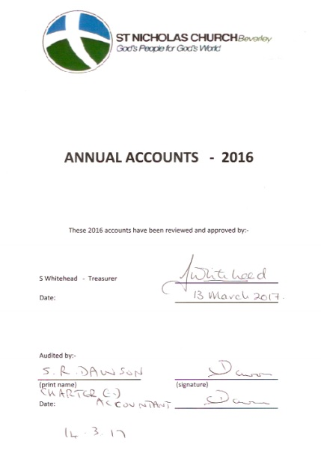

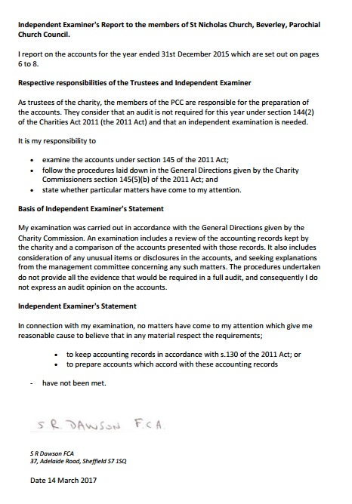

Statement of Financial Activities for the year end 31 December 2016 - St Nicholas Church, Beverley
The financial statements have been prepared in accordance with the Church Accounting Regulations 2007 together with applicable standards and SORP 2015. Where they differ it is noted. The accounts are drawn up on a prepayment and accrual basis. There are no prepayments.
Total Receipts on ordinary unrestricted funds (Church and Centre) where £135,338 and are detailed in the financial statements. In real terms and discounting legacy contributions, receipts from giving increased in the order of £15000 on 2015 mainly as a result of one-off donations.
Total Spending from restricted and unrestricted funds was £102,604 for Christian ministry and centre operations. This included £38,000 to the diocese Free Will Giving (£35,000 2015). Operating costs were slightly lower than the previous year but we had higher maintenance costs for the repair of the Flint room window.
Balance of income and expenditure was -£32,733 compared to -£20750 in 2015. The difference is attributed to the Flint Room Window repair costs. Overall, expenditure has been controlled at levels slightly less than those of 2015. We need to target raising an additional funds annually to close the deficit to a more manageable amount, fortunately we still have a significant legacy to fall back on. It is expected that the Church will require a significant sum for repair works to the roof over the next two years and much prayer needs to be given to how this will be funded.
Current Assets
- Debtors consist primarily of £14000 owing from HMRC for 2016 Gift Aid and £2175 owed by Centre Users (£1600 has since been paid into our accounts)
- Stock Valuations – Arts and crafts Stock was valued at £1563
Legacies and Investments - There were no new restricted receipts for the year. We received £49560 from Trevor Smith’s estate and from £10,000 CLT Walker’s estate. We also received £8649 from Church Members during the year which have been used to fund improvements such as the new bench cushions. We are truly thankful for the generosity of our Church community as a whole.
The investment portfolio that continued to be managed by Cardales was valued at £123,095; £23,000 was withdrawn from this account to part pay the Dioceses Free Will Offering (the balance was paid from the general Church account fund). Given that the start of year balance was £139,688 the account has seen improved returns (£6407) in line with stock market improvements.
Property, assets and cash holding – consecrated and benefice property is not included in the accounts by s96(2) of the Charities Act (1993). The Community centre is insured (Building and contents) for £1.82M and the Church £4.36m. Furniture and equipment is depreciated on a straight line basis over 4 years. Items under £1000 are written off in the year of purchase. In 2016, a microphone system and the cushions where purchased for Church use at a cost of £3865.42. These items have been depreciated for the first year at £967.
Reserves Policy – The PCC does not have a reserves policy to maintain a balance of unrestricted funds to cover emergency situations that may arise, any shortfall in the general accounts is made up from reserves by agreement at PCC meetings. The reserves held in all accounts at 30/12/2016 totalled £214,581.55
Staffing Costs – Nicola Bray replaced Charlotte Thomson in the part-time Parish Administrator role in September. Charlotte left to take up a new full-time position and we wish her every success in the future. Joy Thomson continued in her role as Centre Cleaner / Caretaker but has handed the play group leader role to Nicola due to other commitments. Sophie Taylor continued her cleaning role at the Church. All staff are paid at the National Living Wage rate with up-ratings paid in April.
Accounting Notes:
- Planned Giving includes
  - Covenanted amounts – the net income not including the amount claimed from the HMRC under the Gift Aid scheme
  - Uncovenanted amounts – Amounts given outside the gift Aid scheme for which nothing is claimable from the HMRC
  - Donations and appeals – additional amounts raised from specific fund raising campaigns.
  - Fund raising events (Church) – Book sales, fetes, etc.
- Fee Income – Income from weddings, funerals, etc.
- Giving to Missionary societies – amounts given to support local charities and societies both local and abroad
- Home Mission – amounts spent on missionary work in the local community



 